**ABSTRACT**

Cricket Score Sheet Management: This project includes the process of entering and recording the respective details of the players such as their names, the number of balls they have played, the number of runs they have hit, their batting and bowling status etc. It also includes the feature of calculating the total balls played and total score hit by the batting team as well as total overs bowled by the bowling team. It displays the final score sheet in the end with all the necessary details of each individual player and shows the status of the game. This project aims at reducing the time involved in entering the scores manually in paper and helps in minimalizing human errors while entering the scores. This project uses C language to execute the task effectively and is compatible with different hardware used in mobiles & PC’s.

**CHAPTER 1**

**INTRODUCTION**

**1.1 OVERVIEW**

The sport cricket is a huge deal in India and there are a lot of small and new places where cricket is being played and is being coached and this is where our project comes into play , as a lot of matches are played and the management of score and other data was done manually using score sheets and this is not very user friendly and the data may be faulty as human error are possible but by using this management system most of the human error are reduced this systems allows the used to update the game details and helps in proper maintenance of scores and other player data which allows in better analysis and developments of players and the process is simplified as entry of data is very user friendly and straight forward this is mainly aimed for the lower level cricketing aspects like local cricket coaching centres and local cricket matches and tournaments played.

**1.2VISION AND MISION**

VISION: to develop better technological infrastructure and the development of sports industry.

MISSION: to make technology accessible to everyone in a very minimalistic and easy way

# 1.3OBJECTIVES

To provide various options to enter details such as score, wickets, overs, etc.

1. To display the details entered and print the same.
2. To be compatible with wide range of hardware used in PC’s and mobile devices

**1.4 SCOPE**

Current system is a paper-based system which is not feasible in today’s world, so this system aims at reducing the time frame involved in generating scorecards and also reduce workload.

# 1.5 PROBLEM STATEMENT

To design and develop software for Cricket Scorecard Management system.

**CHAPTER 2**

**SYSTEM REQUIREMENTS**

**2.1 HARDWARE REQUIREMENTS**

* PC:
* Processor: Pentium IV/Dual core/Core duo processors
* RAM: 512 MB/1GB and above
* Hard disk: 512 GB [1/2 GB]

Billing Machine:

* Any architecture such as RISC & CISC

**2.2 SOFTWARE REQUIREMENTS**

* PC:
* Programming language: C/C++
* Operating System: Windows XP/7/8/10 or Linux

Billing Machine:

* Compatible with different types of architecture such as RISC & CISC.

**2.3 FUNCTIONAL REQURIEMENTS**

These are statements of services the system should provide; it defines how the system should behave in particular situations and how it should react to particular inputs. In some cases, the functional requirements may also explicitly state what the system as a whole.

* To provide various options to enter details such as score, wickets, overs and also player details.
* To display the details entered and print the same.
* To be compatible with wide range of hardware used in PC’s and mobile devices.

**2.4 NON- FUNCTIONAL REQUIREMENTS**

These requirements are not directly concerned with the specific functions delivered by system and may relate to emergent system properties such as reliability, response time and store occupancy.

* Maintainability: Software should be written in such a way that it may evolve to meet the changing needs of customers.
* Usability: Software must be usable, without undue effort, by the type of user for whom it is designed.
* Security: Software should be secured i.e.; it has to make sure that unauthorized users cannot attack software and the information security is maintained.

**CHAPTER 3**

**SYSTEM DESIGN**

All systems involve interaction of some kind. Modeling user interaction helps to identify user requirements. Here we use related approaches to interaction modeling that models’ interactions between external actors and a system.

1. Use case modeling
2. Sequence Diagrams

**3.1 USE CASE DIAGRAM FOR PETROL BUNK MANAGEMENT SYSTEM**

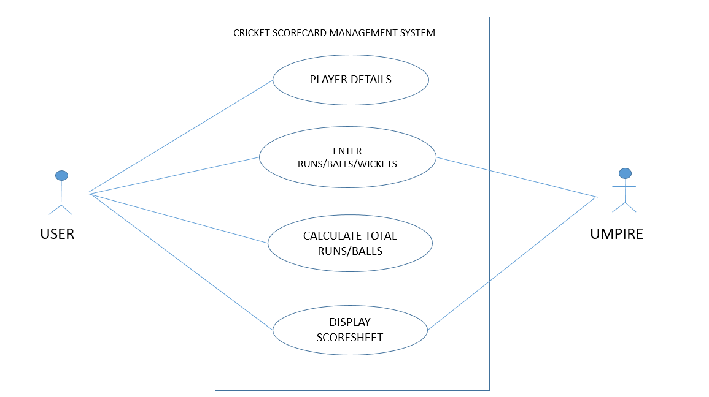

Fig 1: Use case diagram of contact management system

**3.2 SEQUENCE DIAGRAM FOR PETROL**

**BUNK MANAGEMENT SYSTEM**

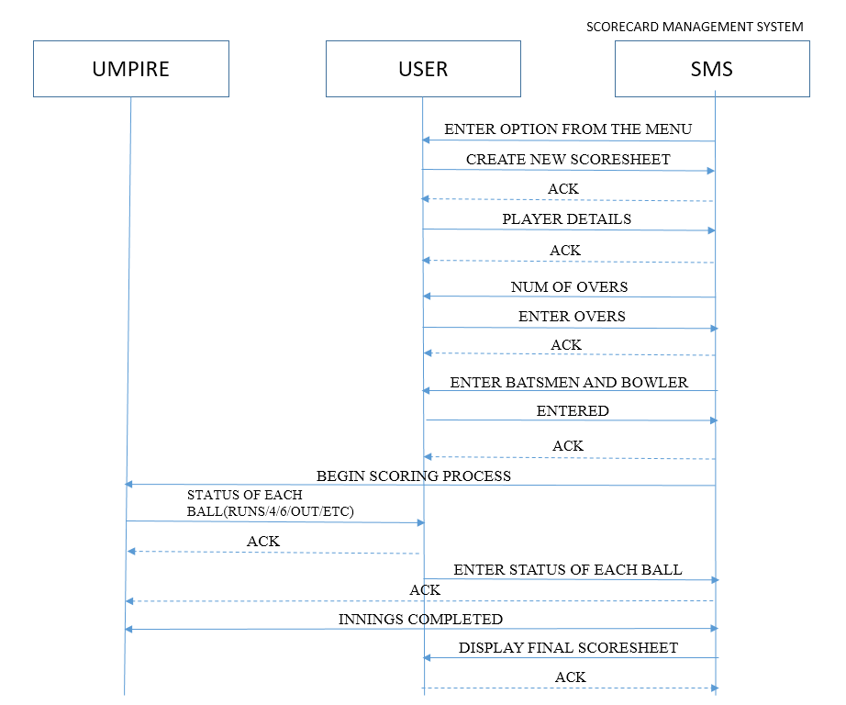 Fig 2: Sequence diagram of contact management system

**CHAPTER 4**

**IMPLEMENTATION**

**4.1 OVERVIEW OF MODULES AND COMPONENTS**

**4.1.1 DATA STRUCTURE USED**

* Main data structure used in the program is **array of structures**. It is used to store the details of team players such as their names(char), runs scored(int), out or not out(boolean), balls played(int), ID(int).
* Other basic data types such as int, char, float, boolean is used for values such as name, runs scored, ID etc.

**4.1.2 FUNCTIONS USED**

1. void mainMenu() : This function contains the menu used in the program. It displays the options provided by the program which are :

1. Create new scoresheet.

2. Exit.

2. void teamDetails() : This function is used to get the details of the team players from the user. Batting team and bowling team player names are entered by the user here.

3. void scoringProcess() : This function handles all the process required in entering and recording the scores, balls played etc. and calculating the total score and total balls played by the team.

4. void scoreSheet() : This function is used to display the final scoresheet after the scoring process is finished.

**CHAPTER 5**

**RESULTS**

**5.1 OUTPUT SCREENSHOTS**

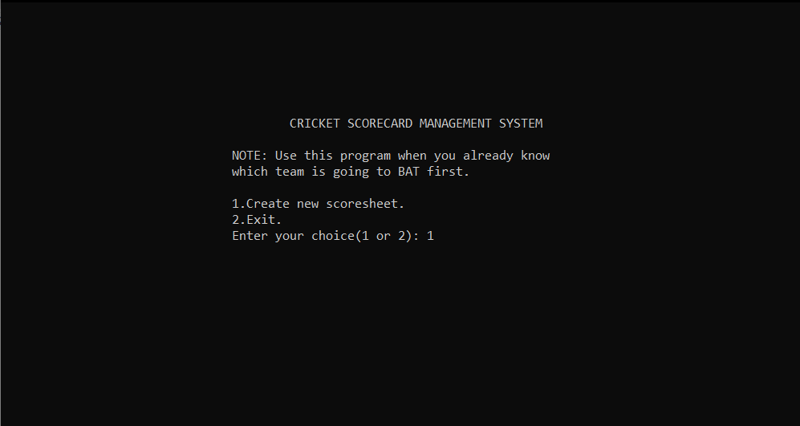

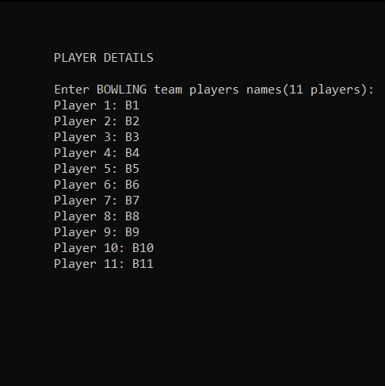

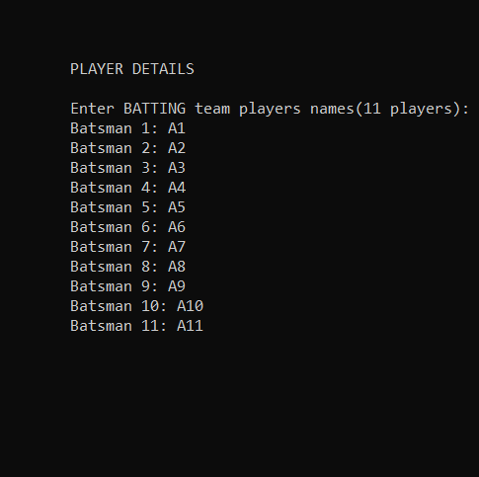

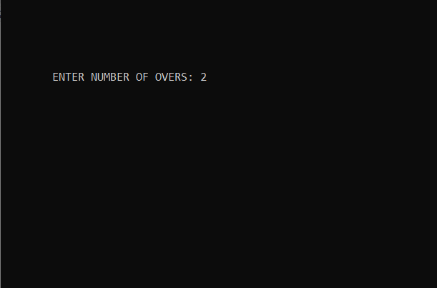

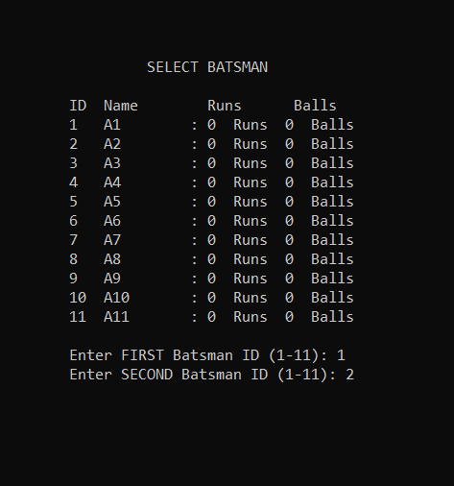

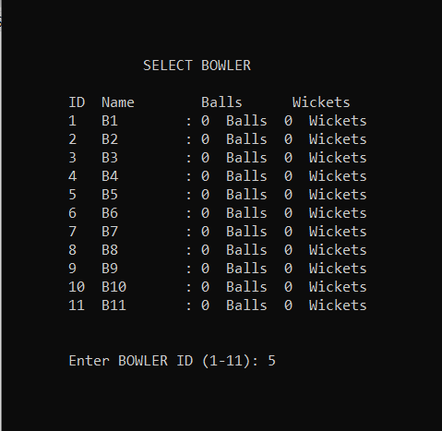

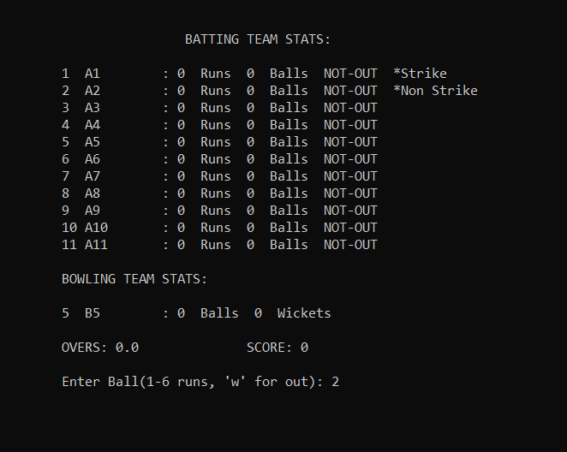

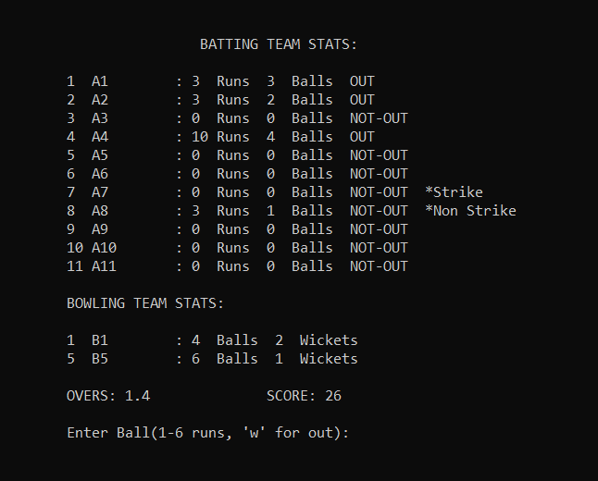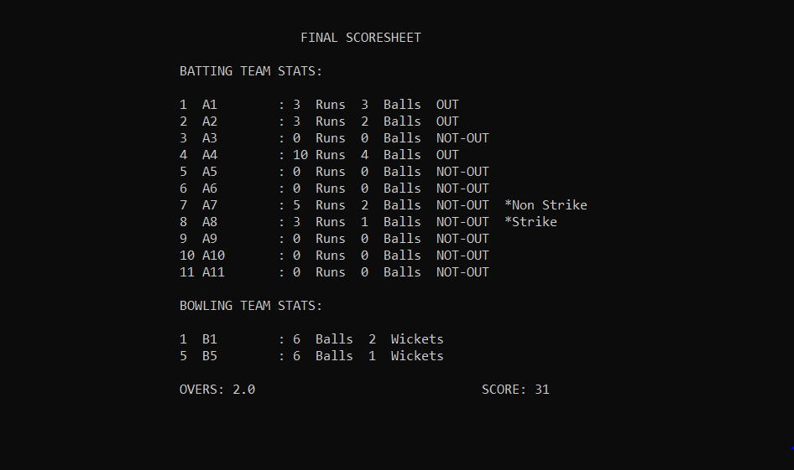

**CHAPTER 6**

**CONCLUSION**

With today’s advancement in technology many things can be simplified especially with the advancement in IT field real world problems like managing and entering details has become easier this project simplifies task such as entering match details and player details thus eliminating the complexity and time involved.IT allows user to instantly enter details and generate score sheets unlike the paper based system where a lot of time is wasted in writing down the details,it also makes data more easy and understandable this proved a easier way of entering the complex data such as runs scored per ball and who got out at what places and other details as such thus creating a better option for entering scores and cricketing data.

**REFERENCES**

* Balaguruswamy .E.Programming In ANSI C,the Tata McGraw-Hill Companies,8th Edition,2008.
* KanetKar Yashvanth, Let Us C,BPB Publication, 9th Edition 2009.
* Gottfriend, Baryon S, Schaum’s outlines programming with C, the Tata McGraw-Hill, 2007.
* C. Ganesh, Fuzzy logic –based inferencing in the presence of input data uncertainty, January 1998.
* M. Stonebraker, E.N.Hanson, S.Potamianos, IEEE Trans on software engineering, vol.14, no.7, pp.897-907, july 1988.